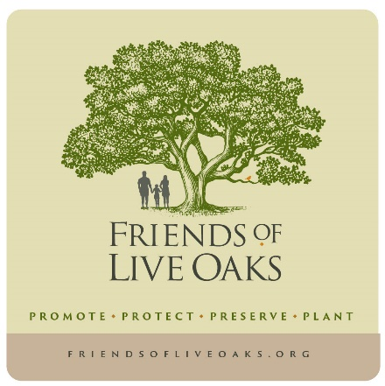
Meeting Agenda
Tuesday May 19, 2026, 4:15 - 5:30 PM
Oyster Conference Room @ Brock Environmental Center
3663 Marlin Bay Drive, Virginia Beach, VA 23455
Zoom Option

- Introductions; Review Agenda for Additions, Corrections, Etc.

- April 20, 2025 Meeting Actions, Director Report, Secretary Report, Treasurer Report

- Administrative Matters (Fund Balance $8,382.05, Membership Dues Reminder, Kroger Community Rewards Program, Crutchfield Realty Donation)

- Old Business:
- Update: Shore Drive Phase III Tree Impacts, Mitigation & Landscaping Plan; State Legislative Agenda; AREC Live Oak Nursery; Social Media and Website; Pleasure House Point Wetlands Bank Mitigation Site; ESP Student Recognition Project; Bayside Baptist Church Tree Pruning; VNG Live Oaks; Treasure Map Project; City Tree Fund; Partnerships; VDOF Wall of Wood; Mark Warren Live Oak Acorn Propagation Video; City Code Work Group, MTG to Transfer Facebook Account Administrator, Marlin Bay Live Oak Cleanup, ESP Live Oak Wood Planing, Remove Invasive Plants at CBF Pleasure House Point

- New Business:
- Brian Friedman Briefing re: Friends of Lambert’s Point City Park in Norfolk
- Review Events Calendar (see reverse side for scheduled events; 10/10/26 Master Gardener Fall Festival; 11/14/26 Tree Adoption Event)
  - Proposed Events (dates TBD; Ocean View Civic League Presentation; Tree Workshop with LRNOW; LRNOW Fall Festival ; ESP Live Oak Planting Dedication)
- VDOF Grant for Acorn Propagation Update
- Schedule City Code Work Group MTG
- Tree Harvesting & AREC Nursery Maintenance Work Days
- Schedule Shore Drive Demo Project Work MTG
- Green Ribbon Committee Tree Subcommittee

- Future Business:
- AREC Maritime Forest Demo Garden
- Virginia Beach Live Oaks Photo Collection
- DEQ Tree Planting BMP Draft Regulations

- 2026 Priorities
- Adoption of City Ordinance re: Protecting Live Oaks on City Property
- Private Property Deed Restrictions to Protect Live Oaks on Private Property
- Achieving City Protection of the Live Oak Grove at Princess Anne Commons
- Pursuing State Legislation & City Ordinances for Greater Tree Protection

- Undertaking a Commercial Property Demonstration Project for Restoring Live Oaks in the Shore Drive
Corridor
- Transplanting Live Oaks to Properties for Protection from Development Activity
- Working to Protect Remaining Pleasure House Point Natural Area Live Oaks and to Plant More Where
Possible

- Existing / Future Partnerships:
- Chesapeake Bay Foundation, Virginia Native Plant Society, Lynnhaven River NOW, Virginia Department of
Forestry, McDonald Garden Center, Virginia Beach Garden Club, Virginia Tech Hampton Roads Agricultural
Research and Extension Center, Virginia Beach City Public Schools Environmental Studies Program, Virginia
Beach Landscape Management, Virginia Master Naturalists Tidewater Chapter, First Landing State Park,
Virginia Cooperative Extension Virginia Beach Master Gardeners, Southern Branch Nursery, Ladyfern,
Westminster-Canterbury, VA Coastal Zone Management Program Native Plant Marketing, Live Oak
Real Estate, Crutchfield Realty, Lowe’s, Home Depot, VNG, Dominion Power

- Summarize; Review Meeting Actions; Review Assignments and Items for Next Meeting

- Adjourn

Next Meeting Date/Time/Location: Monday June 15, 2026 / 4:15 PM / Virginia Beach Environmental Studies Program Academy, Macon and Joan Brock Center Classroom @ Brock Environmental Center -
3663 Marlin Bay Drive, Virginia Beach, VA 23455

https://friendsofliveoaks.org/

EVENT CALENDAR

SUN | MON | TUE | WED | THU | FRI | SAT
5/10  Mother’s Day | 5/11 | 5/12 | 5/13 | 5/14  Ascension Day | 5/15 | 5/16
5/17 | 5/18 | 5/19  4:15 PM FOLO MTG @ Brock ESP Classroom | 5/20 | 5/21 | 5/22 | 5/23
5/24  Pentecost | 5/25  Memorial Day | 5/26 | 5/27  Eid al-Adha | 5/28  Armed Forces Day | 5/29 | 5/30
5/31 | 6/1  LGBTQ+ Pride Month Begins | 6/2 | 6/3 | 6/4 | 6/5 | 6/6  D Day
6/7 | 6/8 | 6/9 | 6/10 | 6/11 | 6/12 | 6/13
6/14 | 6/15  4:15 PM FOLO MTG @ Brock ESP Classroom | 6/16 | 6/17 | 6/18 | 6/19 | 6/20

